Tenda F3--How to Setup WISP mode

Step 1: Login the homepage.

- Open a browser then type “192.168.0.1” into the Address Bar, press Enter. Then enter the password of this page. Tap “Login”.

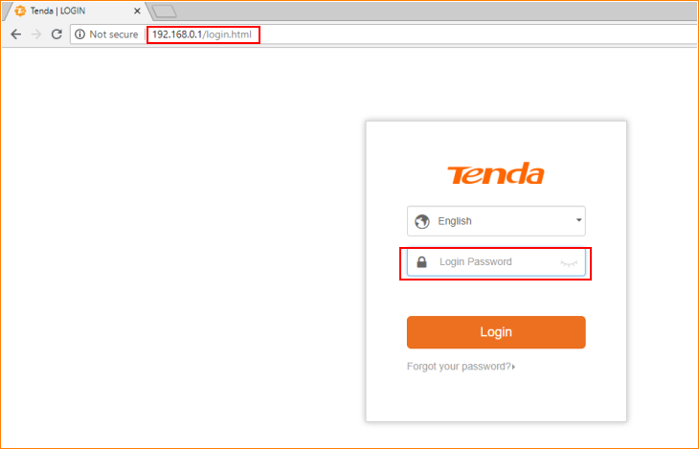

Note: The default password is shown on the bottom of the router. If you have changed it and you also forgot it, see “Forget your password?” below the “Login” button.

- Then the interface will turn into the homepage, tap “Wireless Repeating”, you can see “WISP” option in this page.

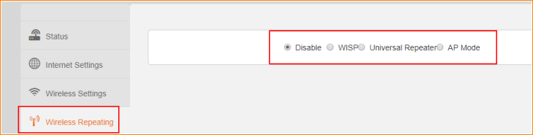

Step 2: Setup WISP

- Tap “WISP”, select your uplink Wi-Fi signal, type its password, and tap “OK” to save all the settings.

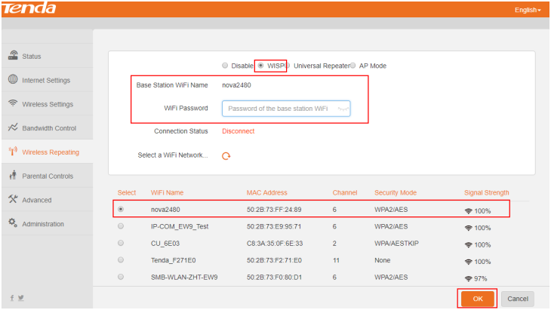

- Tap “OK” on the pop window, then the router will reboot automatically.

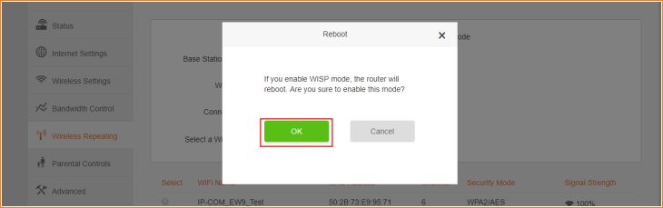

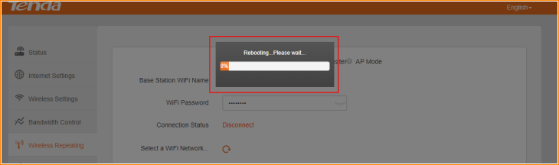

- After rebooting, login the homepage again, and tap “Status” to check the Connection Status of router. If the Connection Status is shown as below, that means you setup WISP successfully.

